**Aid Hive**

(Blood Donation Management System)



*Under the supervision of*

Prof. Imran Shafique

Bachelor of Science in CS/IT (2021-2025)

Department of Information Technology,

Government Islamia College, Gujranwala

**Aid Hive**

A project presented to

Government Islamia College, Gujranwala

In partial fulfilment

of the requirement for the degree of

Bachelor of Science in Information Technology (2021-2025)

By

|  |  |
| --- | --- |
| Abdur Rehman | 2021-ICG-663 |
| Ammad Ahmad | 2021-ICG-97 |
| Ali Hassan | 2021-ICG-120 |
| Hafiz Maaz Ahmad Siddiqi | 2021-ICG-117 |

Bachelor of Science in CS/IT (2021-2025)

Department of Information Technology,

Government Islamia College, Gujranwala

**DECLARATION**

We, the undersigned members of the project team, hereby confirm that the software system titled "Aid Hive: Blood Donation Management System", along with its documentation, is our own original work. We also confirm that this project, in whole or in part, has not been plagiarized from any source, nor has it been submitted previously for any degree, diploma, or qualification at this or any other university or institution of learning. In the event any part of this work is determined to be a plagiarized work or copy of any other project, we take full responsibility for the same. This project and report have been designed and prepared by our team from scratch under the guidance of our revered supervisor.

Signature: --------------------------- Signature: ---------------------------

Abdur Rehman 073151 Ammad Ahmad 056503

Signature: --------------------------- Signature: ---------------------------

Ali Hassan 056427 Hafiz Maaz Ahmed Siddiqi 056430

**CERTIFICATE OF APPROVAL**

It is to confirm that the final year design project (FYDP) of BS-IT "Blood Donation Management System" was prepared by **Abdur Rehman (2021-ICG-663), Ammad Ahmad (2021-ICG-97), Ali Hassan (2021-ICG-120),** and **Hafiz Maaz Ahmad Siddiqi (2021-ICG-117)** under the guidance of **"Prof. Imran Shafique"** in my view; it is complete enough, in scope and quality, for the award of Bachelors of Science in Information Technology.

**Signature: ---------------------------------------**

**FYDP Supervisor: Prof. Imran Shafique**

**Signatures (Faculty Advisory Committee (FAC)**

|  |  |  |  |
| --- | --- | --- | --- |
| **Signatures** |  |  |  |
| **Name** |  |  |  |
|  |  |  |  |

**Signature: ---------------------------------------**

**Head of FYDP Coordination Office:**

**Signature: --------------------------------------- Dated: ________________**

**Chairperson, Department of Information Technology**

**Executive Summary**

Aid Hive is a web-based application that connects donors of blood and recipients. It is built on the MERN stack, whereas MySQL is implemented as the database for secure and dependable data storage. The application has five primary pages: Home, Donate, Find Blood, Aid Hive Workers, and About Us, in addition to an Aid Hive Admin panel, which can be accessed by login. Donors and recipients can only access the system after filling up the registration form to provide authenticity and safety. The system is easy, effective, and user-friendly to save time, efficiently manage blood donations, and eventually save lives.

**Acknowledgement**

First and foremost, we express our gratitude to Allah Almighty whose blessings have enabled us to accomplish our Final Year Project successfully. We are truly grateful to our honorable supervisor, **Prof. Imran Shafique**, for his constant support, guidance, and encouragement. We are thankful for the assistance of **Mr. Usman Ahmed** for this project. We thank our teachers, classmates, and everyone who offered suggestions and feedback. Lastly, we appreciate our friends and families for their encouragement and support, which enabled us to carry out this project.

Signature: --------------------------- Signature: ---------------------------

Abdur Rehman 073151 Ammad Ahmad 056503

Signature: --------------------------- Signature: ---------------------------

Ali Hassan 056427 Hafiz Maaz Ahmad Siddiqi 056430

Table of Contents

1. Introduction 2

1.1 Problem Statement 2

1.2 Problem Solution 2

1.3 Objectives of the Proposed System 2

1.4 Scope 3

1.5 System Components 3

***1.5.1 Pages of the System*** 3

***1.5.2 Buttons of the System*** 3

***1.5.3 Donor and Recipient Forms*** 3

***1.5.4 Admin Login*** 3

***1.5.5 Database (MySQL)*** 4

1.6 Related System Analysis/Literature Review 4

1.7 Vision Statement 5

1.8 System Limitation and Constraints 5

***1.8.1 System Limitations:*** 5

***1.8.2 System Constraints:*** 5

1.9 Tools and Technologies 6

***1.9.1 Frontend*** 6

***1.9.2 Backend*** 6

***1.9.3 Database*** 6

***1.9.4 Development Tools*** 6

1.10 Project Planning 8

1.11 Summary 8

2. Analysis 10

2.1 User Functions and Characteristics 10

2.2 Requirement Identifying Technique 13

2.3 Functional Requirements 17

***2.3.1 Functional Requirement 1*** 17

***2.3.2 Functional Requirements 2*** 18

***2.3.3 Functional Requirement 3*** 18

***2.3.4 Functional Requirement 4*** 19

***2.3.5 Functional Requirement 5*** 20

2.4 Non-Functional Requirements 21

***2.4.1 Reliability*** 21

***2.4.2 Useability*** 21

***2.4.3 Performance*** 22

***2.4.4*** ***Security*** 22

2.5 External Interface Requirements 22

***2.5.1*** ***User Interfaces Requirements*** 22

***2.5.2*** ***Software interfaces*** 23

***2.5.3*** ***Hardware interfaces*** 23

***3.5.4 Communications interfaces*** 24

2.6 Summary 25

3. System Design 27

3.1 Design considerations 27

3.2 Design Models 28

***3.2.1*** ***Donor Registration Sequence Diagram*** 34

***3.2.2 Recipient Registration Sequence Diagram*** 36

***3.2.3*** ***Admin Panel Sequence Diagram*** 38

***3.2.4 Recipient State Transition*** 42

3.3 Architectural Design 43

3.4 Data Design 46

***3.4.1*** ***Data Dictionary*** 48

3.5 User Interface Design 49

***3.5.1*** ***Screen Images*** 51

***3.5.2*** ***Screen Objects and Actions*** 56

3.6 Behavioral Model 59

***3.6.1*** ***Admin login*** 59

***3.6.2***  ***List of Worker / Add Worker*** 60

***3.6.3*** ***Delete Worker*** 61

***3.6.4*** ***Display Listed Donors*** 62

***3.6.5*** ***Display Listed Recipient*** 63

***3.6.6*** ***Logout*** 64

***3.6.7*** ***Donor Registration*** 65

***3.6.8*** ***Recipient Registration*** 66

***3.6.10***  ***Admin Login*** 68

***3.6.11***   ***List of Worker / Add Worker*** 69

***3.6.12***  ***Delete Worker*** 70

***3.6.13***  ***Display Listed Donor / Recipient*** 71

***3.6.14 Donor / Recipient Registration*** 72

***3.6.15 Donor / Recipient Display Worker List*** 73

3.7 Design Decisions 74

3.8 Summary 74

4. Implementation 76

4.1 Code Repository 76

4.2 Summary 77

5. Introduction 79

5.1 Unit Testing (UT) 79

***5.1.1*** ***Donor Registration*** 80

***5.1.2*** ***Recipient Registration*** 81

***5.1.3*** ***Admin Login*** 82

5.2 Functional Testing (FT) 83

***5.2.2*** ***Recipient Registration*** 84

***5.2.3*** ***Admin Login*** 85

***5.2.4*** ***Admin Panel Controls*** 85

5.3 Integration Testing (IT) 86

***5.3.1*** ***Request Submission Flow*** 86

***5.3.2*** ***User Login Blocked*** 87

***5.3.3*** ***Matches with User History*** 87

5.4 Performance Testing (PT) 88

***5.4.1*** ***Login API Response Time*** 88

***5.4.2*** ***Request Creation Under Load*** 89

***5.4.3 Admin Panel Performance*** 89

5.5 Summary 90

6. Introduction 92

6.1 Conversion Method 92

6.2 Summary 94

7. Introduction 96

7.1 Evaluation 96

7.2 Traceability Matrix 97

7.3 Conclusion 98

7.4 Future Work 98

**References** 99

Appendix A 100

Use case Description Template 100

**List of Table**

Table 1: Related System Analysis with proposed project solution 4

Table 2: Tools and Technologies for Proposed Project 7

Table 3: Project Planning Gantt Chart 8

Table 4: System Functions and User Characteristics 12

Table 5: Use Case List 15

Table 6 :Donor Registration 17

Table 7 :Recipient Registration 18

Table 8 : Search Donors 18

Table 9 : Admin login 19

Table 10 : Manage Records 20

Table 11 : Database Management 21

Table 12: Data Dictionary Table 48

Table 13 : Functions and Function Parameters 49

Table 14: Use case 1 56

Table 15: User Registration 80

Table 16: Recipient Registration 81

Table 17: Admin Login 82

Table 18: Find Blood 83

Table 19: Donor Registration 84

Table 20: Recipient Registration 84

Table 21: Admin login 85

Table 22: Admin Control 85

Table 23: Test Case 1 86

Table 24: Test Case 2 87

Table 25: Test Case 3 87

Table 26: Test Case 1 88

Table 27: Test Case 2 89

Table 28: Test Case 3 89

Table 29 : Evaluation Table 96

Table 30 : Requirement Traceability Matrix 97

Table 31 : Correlation Table 98

Table 32 : Show the detail use case template and example 101

**List of Figures**

Figure 1: Use Case of Aid Hive 16

Figure 2: Component Diagram 30

Figure 3: Donor Registration Sequence Diagram 34

Figure 4: Recipient Registration Sequence Diagram 36

Figure 5: Admin Panel Sequence Diagram 38

Figure 6:Donor State Transition Diagram of Aid Hive 40

Figure 7 : Recipient State Transition Diagram 42

Figure 8: Architectural Design of Aid Hive 45

Figure 9 : ER Diagram 47

Figure 10 : Landing Page 52

Figure 11 : Admin Login Form 53

Figure 12 : Donor Registration Form 54

Figure 13 : Recipient Registration Form 55

Figure 14: Admin login 59

Figure 15: List of Worker / Add Worker 60

Figure 16: Delete Worker 61

Figure 17: Display Listed Donor 62

Figure 18 : Display Listed Recipient 63

Figure 19: Logout 64

Figure 20: Donor Registration 65

Figure 21: Recipient Registration 66

Figure 22: Donor / Recipient Display Worker List 67

Figure 23 :Admin Login 68

Figure 24: List of Worker / Add Worker 69

Figure 25: Delete Worker 70

Figure 26: Display Listed Donor / Recipient 71

Figure 27: Donor / Recipient Registration 72

Figure 28: Donor / Recipient Display Worker List 73

**Chapter 1**

**Introduction**

# **1. Introduction**

## **1.1 Problem Statement**

In critical cases, the majority of patients suffer from long delays in getting blood donations since there is no platform with real-time capabilities. The current platforms lack real-time donor location tracking, priority notifications, and instant communication between donors and recipients. Our project Aid Hive is likely to bridge this gap with a trustworthy platform that provides real-time cap abilities for connecting donors and patients.

## **1.2 Problem Solution**

To overcome the issue of delayed blood donation, we have created Aid Hive as an online real-time platform where the patients and donors are matched first. Our system has real-time location tracking, emergency alert, and secure messaging in a manner that the patients are helped immediately without any delay. The donor and patient easily locate the donors nearby, order the blood, and get instant alerts. The donors can respond instantly too, and both can chat in real-time. Aid Hive also monitors donations and has an easy, simple-to-use dashboard. With these features, our project removes loopholes from current systems and makes blood donation faster, smarter, and reliable, particularly in emergency cases.

## **1.3 Objectives of the Proposed System**

Our project Aid Hive is a blood donation management system developed using the MERN stack and MySQL database. The main aim of this system is to possess a quick, easy, and safe way of bringing donors and recipients together. Our aim is to provide patients with an easy way to discover compatible donors based on blood type and geography. Recipients and donors can be registered in the system by completing forms without going through a complex login or signup process. Logging in to manage the site is privileged only by the admin. The system also has an online location tracking through Google Maps, where patients can conveniently locate nearby donors or Aid Hive workers. Along with this, emergency requests will be relayed through real-time alerts and notifications, which will ensure prompt response and faster communication.

## **1.4 Scope**

The functionality of our project Aid Hive is to provide an online blood donation management system that makes the process easier and faster. The system is built using the MERN stack, and MySQL is used as the database to store donor and receiver details. Our project contains five main pages: Home, Donate, Find Blood, Aid Hive Workers, and About Us. It also encompasses two principal buttons: Aid Hive Admin login and Live Location Tracking. They make the system easy to use such that it becomes extremely user-friendly and simple to operate.

## **1.5 System Components**

The Aid Hive system is made up of different components that work together to provide blood donation management.

### ***1.5.1 Pages of the System***

The system has five main pages:

* **Home Page:** Gives an overview and easy navigation.
* **Donate Page:** Donors fill a form with their details to register as donors.
* **Find Blood Page:** Recipients fill a form to request blood.
* **Aid Hive Workers Page:** Shows information and live location of workers.
* **About Us Page:** Provides project and team information.

### ***1.5.2 Buttons of the System***

The system has only one main button:

* **Aid Hive Admin Button:** Only for admin login.

### ***1.5.3 Donor and Recipient Forms***

Donors and recipients can join by filling forms with their details. No login is required for them.

### ***1.5.4 Admin Login***

Login is only available for the admin. The admin can manage donor/recipient data and oversee the system.

### ***1.5.5 Database (MySQL)***

The system uses MySQLdatabase to store donor details, blood requests, and history records safely.

## **1.6 Related System Analysis/Literature Review**

There are several online systems for donating blood that are already in use, but they do not fulfil the emergency requirements efficiently. In Pakistan and other countries, none of these available systems are well-equipped or user-friendly. The following is a brief overview of some of these existing systems and how our project Aid Hive is better.

Table 1: Related System Analysis with proposed project solution

|  |  |  |  |
| --- | --- | --- | --- |
| **System / Website** | **Main Features** | **Limitations** | **Aid Hive Improvements** |
| **Sehat Kahani Blood Services** | Connects hospitals and patients for arranging blood donations. | Focused on hospitals only, no real-time donor location, and not open for all users. | Aid Hive is open for everyone and allows direct connection between donor and recipient. |
| **Red Cross Blood Services** | Large-scale international donor management system with hospital integration. | Complicated system, not user-friendly for local or individual needs, requires multiple steps. | Aid Hive is lightweight, simple, and localized for quick use in all over the Pakistan. |
| **Aid Hive (Our System)** | Donor and recipient form filling, MySQL database, 5 web pages, and admin login. | Does not include automated push notifications or SMS alerts. | Focused on simplicity, visibility, and easy access. |

## **1.7 Vision Statement**

Aid Hive's vision is to create a reliable, accessible, and technology-driven blood donation management system that brings donors and recipients together in real time. Through integrating safe storage space for data, live tracking of location, and efficient matching of recipients and donors, the system aims to reduce delays in the event of an emergency, provide transparency, and promote a culture of voluntary blood donation. Aid Hive will, in the near future, extend its platform to hospitals, blood banks, and medical organizations and become an online trusted portal for lifesaving blood donation services.

## **1.8 System Limitation and Constraints**

### ***1.8.1 System Limitations:***

1. The system does not provide real-time alerts or notifications. Users must check the platform themselves.
2. Only the admin has a login system. Donors and recipients can only fill forms; no personal accounts are created for them.
3. The system works only with an active internet connection. Without internet, it cannot be used.
4. The database is limited to MySQL, which may face challenges if the system is scaled to a very large number of users.
5. There is no direct integration with hospitals or blood banks at this stage.

### ***1.8.2 System Constraints:***

1. **Technology Constraint:**  
   The system is built using the MERN stack with MySQL database, so it is limited to web-based usage only.
2. **Connectivity Constraint:**  
   Continuous internet connection is required for form submission, database access.
3. **Hardware Constraint:**  
   Users need a device (desktop, laptop, or smartphone) with a browser and GPS support for location tracking.
4. **User Constraint:**  
   Only the admin has login access. Donors and recipients can interact with the system only through form filling.
5. **Data Constraint:**  
   The system stores information only in the MySQL database, which requires regular maintenance and optimization when data grows larger.

## **1.9 Tools and Technologies**

The following tools and technologies were used to develop Aid Hive (Blood Donation Management System):

### ***1.9.1 Frontend***

* **React.js:** For building the user interface.
* **CSS:** For styling and layout of web pages.

### ***1.9.2 Backend***

* **Node.js:** For server-side logic.
* **Express.js:** For connecting frontend with backend.

### ***1.9.3 Database***

* **MySQL:** To store and manage donor and recipient information.

### ***1.9.4 Development Tools***

* **Visual Studio Code (VS Code):** Code editor.
* **npm (Node Package Manager**): For installing and managing dependencies.
* **GitHub:** For version control and team collaboration.

Table 2: Tools and Technologies for Proposed Project

|  |  |  |
| --- | --- | --- |
| **Category** | **Technology / Tool** | **Purpose** |
| **Frontend** | React.js | To build the user interface of the system. |
|  | CSS | For styling and layout of web pages. |
|  | Framer Motion | For smooth animations and transitions. |
| **Backend** | Node.js | For server-side scripting and logic. |
|  | Express.js | To handle APIs and connect frontend & backend. |
| **Database** | MySQL | To store and manage donor and recipient records. |
| **Libraries / APIs** | Axios | To handle HTTP requests between frontend and backend. |
| **Development** | Visual Studio Code (VS Code) | Code editor for development. |
|  | npm (Node Package Manager) | To install and manage project dependencies. |
|  | GitHub | For version control and collaboration. |
| **Security** | Bcrypt | For Hash Passwords. |
|  | Prepared Statements | For SQL injection |
|  | .env | Improves security for easily config. And deploy. |

## **1.10 Project Planning**

Table 3: Project Planning Gantt Chart

|  |  |  |  |  |  |  |  |  |  |  |
| --- | --- | --- | --- | --- | --- | --- | --- | --- | --- | --- |
| **Start Date** | | | | | **January** | **Feb** | **March** | **April** | **May** | **June** |
|  |  |  |  |  |  |
| **Task No.** | **Task** | **Supervisor** | **Start Date** | **End**  **Date** |  |  |  |  |  |  |
| 1 | Project Proposal | Prof. Imran Shafique |  |  |  |  | | | | |
| 2 | SRS and SDS | Prof. Imran Shafique |  |  |  |  |  | | | |
| 3 | RTM | Prof. Imran Shafique |  |  |  |  |  | | | |
| 4 | Frontend | Prof. Imran Shafique |  |  |  |  | |  | | |
| 5 | Backend | Prof. Imran Shafique |  |  |  | |  | |  | |
| 6 | DB Integration | Prof. Imran Shafique |  |  |  | | |  | |  |
| 7 | Test Plans | Prof. Imran Shafique |  |  |  | | | |  |  |
| 8 | Test Report | Prof. Imran Shafique |  |  |  | | | |  | |

## **1.11 Summary**

The Aid Hive Blood Donation Management System has been created to counteract the problems of traditional blood donation such as latency, unverified information, and lack of convenience while searching for appropriate donors. It provides an online-based system where donors and recipients can register through forms, and the system can be easily managed by admins securely. It consists of five main pages (Home, Donate, Find Blood, Aid Hive Workers, About Us) and one main feature button (Admin Login). Built on the MRN stack with MySQL as the database, Aid Hive brings about efficiency, accessibility, and reliability in blood donation activity management.

**Chapter 2**

**Requirements Analysis**

# **2. Analysis**

Analysis stage is involved with understanding the issue with the existing blood donation procedures and defining how the envisaged system will resolve them. It is involved with reviewing existing limitations, identifying the user requirements, and defining the functional and non-functional requirements of the Aid Hive Blood Donation Management System. This stage ensures that system design is based on clear-cut objectives, user requirements, and with regard for feasibility.

## **2.1 User Functions and Characteristics**

The Aid Hive Blood Donation Management System is designed to serve three main categories of users: Donors, Recipients, and Admins. Each user type has specific functions and characteristics that define their role in the system.

**1. Donor**

* **Functions:**
  + Register on the website by filling out the donor registration form.
  + Provide required details such as name, age, gender, blood group, contact information, etc.
  + Become available in the system’s database for recipients to search.
* **Characteristics:**
  + Donors are voluntary individuals who are willing to donate blood.
  + They require a simple and user-friendly registration interface.
  + Their data must be stored securely and made accessible to recipients when required.

**2. Recipient**

* **Functions:**
  + Register on the website by filling out the recipient form with necessary details (name, required blood group, contact number, etc.).
  + Search for available donors based on blood group and geographical location.
  + Request blood through the system in urgent situations.
* **Characteristics:**
  + Recipients are usually patients or attendants in urgent need of blood.
  + They expect quick search results and accurate donor information.
  + Their requests must be handled efficiently to avoid delays in emergencies.

**3. Admin**

* **Functions:**
  + Log in securely through the admin login page.
  + Manage donor and recipient records in the MySQL database.
  + Approve, monitor, or delete any donor or recipient entries if needed.
  + Ensure that the data remains updated, accurate, and secure.
* **Characteristics:**
  + Admins are authorized personnel with full system access.
  + They are responsible for maintaining the privacy and integrity of the system.
  + They must have technical knowledge to handle system operations effectively.

Table 4: System Functions and User Characteristics

|  |  |  |
| --- | --- | --- |
| **User Type** | **Functions** | **Characteristics** |
| **Donor** | • Fill out donor registration form  • Provide details (Name, Age, Gender, Blood Group, Contact, etc.)  • Appear in system database for matching with recipients | • Voluntary individuals willing to donate blood  • Require a simple and user-friendly interface  • Information must be stored securely and accessed quickly |
| **Recipient** | • Fill out recipient registration form  • Search donors by blood group and location  • Submit request in urgent cases | • Usually patients/attendants in urgent need of blood  • Expect fast response and accurate donor details  • Depend on reliable donor availability |
| **Admin** | • Log in securely using admin credentials  • Manage donor and recipient records  • Approve, update, or remove entries  • Monitor blood requests and system activity | • Authorized personnel with full system access  • Responsible for data accuracy, privacy, and security  • Must have technical knowledge to operate system |

## **2.2 Requirement Identifying Technique**

Requirement identifying is the process of determining what the system must do to meet user needs effectively. For the Aid Hive Blood Donation Management System, the following techniques were used to identify and gather requirements:

1. **Interviews with Stakeholders**
   * Discussions were held with potential donors, recipients, and administrators to understand their expectations and challenges.
   * Questions focused on difficulties in current blood donation processes, preferred features, and usability requirements.
2. **Observation of Existing System**
   * Studied current blood donation practices in hospitals and blood banks.
   * Identified delays in donor-recipient communication, lack of centralized data, and inefficiency in emergency cases.
3. **Questionnaires/Surveys**
   * Distributed online and offline forms to gather inputs from volunteers and patients.
   * Collected data on desired features, accessibility preferences, and common issues faced.
4. **Brainstorming Sessions**
   * Group discussions among project members to decide which features are essential.
   * Prioritized functionalities like admin login and donor/recipient forms.
5. **Review of Existing Literature & Systems**
   * Studied similar blood donation management systems and software to identify best practices.
   * Noted features that were missing or needed improvement.
6. **Use Case Technique**
   * The Use Case technique helps analyze how users interact with the system in real-life scenarios.
   * It allows the team to define clear, user-focused features by relating each user action to the corresponding system behavior.
   * This approach ensures that functional requirements are accurately specified, complete, and aligned with actual user needs.

**Outcome:**  
By using these techniques, the project team clearly defined functional and non-functional requirements, ensuring that the system effectively serves donors, recipients, and administrators.

Table 5: Use Case List

|  |  |  |
| --- | --- | --- |
| **Use Case** | **Actors** | **Description** |
| Login | Admin/User | Admin or user logs into the system using valid credentials. |
| Display Listed Workers | Admin | Admin views the list of registered Aid Hive workers. |
| Add Worker | Admin | Admin adds a new worker to the system. |
| Delete Worker | Admin | Admin deletes an existing worker from the system. |
| Display Listed Donors | Admin | Admin views the list of registered blood donors. |
| Display Listed Patients | Admin | Admin views the list of registered patients. |
| Logout | Admin/User | Admin or user logs out from the system. |
| Donate Blood | Donor | Donor initiates a blood donation request. |
| Find Blood Donor | Patient/Recipient | Patients search for available donors and request appointments. |
| List Of Aid Hive Workers | Patient/Recipient | Patients or recipients view the list of Aid Hive workers for assistance. |

Figure 1: Use Case of Aid Hive

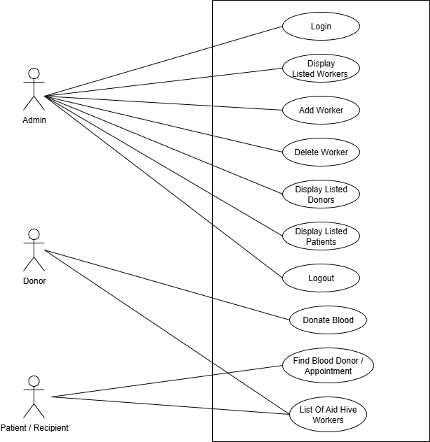

## **2.3 Functional Requirements**

The most important functional requirements of the Aid Hive system. Requirements are grouped by system functions or features with which the users interact. They are developed to address user requirements (donor and recipient) and allow for smooth, consistent, and secure deployment of the application.

### ***2.3.1 Functional Requirement 1***

Table 6 :Donor Registration

|  |  |
| --- | --- |
| **Identifier**: | FR-1 |
| **Title**: | Donor Registration |
| **Description:** | Allow donors to register via an online form by providing personal and contact details |
| **Input Fields:** | Name, Age, Gender, Blood Group, Contact Number, etc. |
| **Processing:** | Validates form data and stores donor information securely in the MySQL database. |
| **Output:** | |  | | --- | |  |  |  | | --- | | Confirmation message of successful registration; donor added to the database for recipient search. | |
| **Dependencies**: | MySQL database for storing data; web form frontend for input; server-side backend for processing. |
| **Priority:** | High |

### ***2.3.2 Functional Requirements 2***

Table 7 :Recipient Registration

|  |  |
| --- | --- |
| **Requirement ID:** | FR-2 |
| **Requirement name**: | Recipient Registration |
| **Description:** | Allows recipients to register their details and blood requests via an online form. |
| **User Type:** | Recipient |
| **Input Fields:** | Name, Required Blood Group, Contact Number, etc. |
| **Processing:** | Validates form data and stores recipient information securely in the MySQL database. |
| **Dependencies**: | MySQL database for storing data; web form frontend for input; server-side backend for processing. |
| **Priority** | High |

### ***2.3.3 Functional Requirement 3***

Table 8 : Search Donors

|  |  |
| --- | --- |
| **Requirement ID:** | FR-3 |
| **Requirement name**: | Search Donors |
| **Description:** | Enables recipients to search for available donors based on blood group and location. |
| **User Type:** | Recipient |
| **Input Fields:** | Blood Group, Location (City/Area) |
| **Processing:** | Matches recipient search criteria with donor records stored in the MySQL database. |
| **Output:** | List of matching donors with contact details and location info. |
| **Dependencies:** | MySQL database for storing donor data; frontend search interface; backend processing for query matching. |

### ***2.3.4 Functional Requirement 4***

Table 9 : Admin login

|  |  |
| --- | --- |
| **Requirement ID:** | FR-4 |
| **Requirement name:** | Admin Login |
| **Description:** | Provides secure login access for administrators to manage system operations. |
| **User Tye:** | Admin |
| **Input Fields:** | Username, Password |
| **Processing:** | Validates admin credentials against records in the MySQL database and grants access to the admin dashboard. |
| **Output:** | Access to the admin panel for managing donors, recipients, and system activities. |
| **Dependencies:** | MySQL database for storing admin credentials; secure backend authentication; frontend login interface. |

### ***2.3.5 Functional Requirement 5***

Table 10 : Manage Records

|  |  |
| --- | --- |
| **Requirement ID:** | FR-5 |
| **Requirement name:** | Manage Records |
| **Description:** | Allows administrators to view, approve, update, or remove donor and recipient records in the system. |
| **User Tye:** | Admin |
| **Input Fields:** | Record ID, Action Type (Approve / Update / Delete), Updated Data (if applicable) |
| **Processing:** | Performs the selected action on the chosen record in the MySQL database and ensures data integrity. |
| **Output:** | Confirmation of successful action (record approved, updated, or deleted). |
| **Dependencies:** | Admin login authentication; MySQL database; backend processing for CRUD operations. |

***2.3.6 Functional Requirement 6***

Table 11 : Database Management

|  |  |
| --- | --- |
| **Requirement ID:** | FR-7 |
| **Requirement name:** | Database Management |
| **Description:** | Stores and manages all donor, recipient, and admin information securely in the MySQL database. |
| **User Tye:** | All Users |
| **Input Fields:** | Donor/Recipient/Admin details entered via forms or admin panel |
| **Processing:** | Validates, stores, retrieves, updates, and deletes records as per user actions; ensures data integrity and security. |
| **Output:** | Accurate storage and retrieval of user information; updates reflected in the system in real-time. |
| **Dependencies:** | MySQL database; backend server for database operations; secure access control. |

## **2.4 Non-Functional Requirements**

These are quality requirements for how well the Aid Hive system works and performs, not for what the system performs. They are reliability, usability, performance, and security expectations.

### ***2.4.1 Reliability***

It should run without incessant crashing. It should recover from sudden mistakes in a graceful manner without losing information. It should have backup protocols so that essential operations such as posting of blood orders are not lost.

### ***2.4.2 Useability***

Aid Hive must be simple and accessible to everyone, even to non-technical individuals. The most essential functionalities must be within reach in two or three steps, and the interface must be based on known standards and guidelines with accessibility attributes.

### ***2.4.3 Performance***

The system should react to user activities in 2 seconds. It should support 500 simultaneous users and remain responsive even on low-bandwidth cellular networks.

***2.4.4 Security***  
The Aid Hive system ensures security by applying multiple protection mechanisms. User passwords are stored safely using bcrypt hashing. The login process is protected against brute-force attacks through express-rate-limit. SQL injection risks are minimized by using prepared statements with placeholders. Additionally, environment variables are managed with dotenv to keep sensitive information secure.

## **2.5 External Interface Requirements**

Here’s some external interface requirements are as follows:

### ***2.5.1 User Interfaces Requirements***

The web application shall provide an intuitive, responsive, and accessible user interface for the following:

* **Donors** **can:**
  + Register/login
  + Update their profiles
  + See blood requests
* **Recipients** **can:**
  + Search/filter donors by blood group and location
  + Submit a blood request
  + Track request status
* **Admin Panel:**
  + Firstly, login then connect to Aid Hive
  + Accept and reject requests
  + Manage users (donors and recipients)

UI will be built using HTML, Tailwind, JavaScript (React in MERN), and will be fully responsive for all screen sizes. Forms will include validation, tooltips, and error handling.

### ***Software interfaces***

The Aid Hive Blood Donation Management System uses multiple software components to ensure smooth functioning and interaction between different modules. The key software interfaces are:

1. **Front-End Interface (MERN Stack – React & Node.js)**
   * Provides a user-friendly interface for donors and recipients to fill registration forms and search for blood.
   * React ensures dynamic web pages and smooth navigation.
   * Node.js handles requests and communicates with the backend.
2. **Back-End Interface (Express.js)**
   * Acts as the middleware to process requests between the front-end and the database.
   * Handles form submissions, validation, and API requests.
3. **Database Interface (MySQL)**
   * Stores donor, recipient, and admin data.
   * Interfaces with the backend to allow insertion, deletion, updating, and retrieval of records.
   * Ensures data consistency and integrity.
4. **Admin Panel Interface**
   * Allows only admins (through login) to manage donor and recipient records.
   * Provides access to view, approve, or remove entries.

### ***Hardware interfaces***

Since Aid Hive is a web-based application, it does not require specialized hardware. However, certain minimum hardware requirements are necessary for users (donors, recipients, and admins).

**1. User Side (Donors & Recipients)**

* **Device Type:** Desktop computer, laptop, tablet, or smartphone.
* **Minimum Requirements:**
  + Processor: 1.5 GHz or higher
  + RAM: 2 GB or higher
  + Storage: 200 MB free space for browser cache
  + Internet: Stable connection (at least 1 Mbps)
* **Interface:** Users interact with the system through a web browser.

**2. Admin Side**

* **Device Type:** Desktop computer or laptop.
* **Minimum Requirements:**
  + Processor: 2.0 GHz Dual-Core or higher
  + RAM: 4 GB or higher
  + Storage: 500 MB free space
  + Internet: Stable broadband connection
* **Interface:** Admin interacts with the system through a secure login portal.

### ***3.5.4 Communications interfaces***

The Aid Hive system relies on standard communication protocols to interact between users, admin, and the backend system.

**1. Web Communication (HTTP/HTTPS)**

* Users (donors and recipients) and admins access the system through standard web browsers using HTTP/HTTPS protocols.
* HTTPS ensures that all data transmitted between users and the server is encrypted and secure.

**2. API Communication**

* The front-end communicates with the back-end via RESTful APIs implemented in Express.js.
* APIs handle requests such as form submissions, donor searches, admin actions, and live location updates.

**3. Database Communication**

* The back-end communicates with the MySQL database using standard SQL queries for inserting, updating, retrieving, and deleting records.

## **2.6 Summary**

In this chapter, we studied how the Aid Hive Blood Donation Management System interacts with its users and interfaces. Donors and recipients register exclusively through simple online forms, while only the admin has login access to manage records. The system relies on standard web communication (HTTP/HTTPS), a user-friendly front-end, and secure MySQL database connections. This analysis guarantees that the system remains easy to use, reliable, and responsive, especially in urgent blood donation scenarios where timely access to donors is critical.

**Chapter 3**

**Design and Architecture**

# **3. System Design**

The system is based on a MERN stack with a MySQL database with an aim to handle the blood donations optimally. It has a React.js frontend that offers five pages (Home, Donate, Find Blood, Aid Hive Workers, and About Us) and a single critical button for Admin access. Donors and recipients are restricted to interact with the system by submitting registration forms, whereas the admin has to log in to view and manage the complete system features. The backend, developed using Node.js and Express.js, manages all API requests, user login, and database communication with MySQL.

## **3.1 Design considerations**

The design of the system takes into account the scalability, security, and usability. User interfaces are minimalistic and intuitive such that the donor and the recipient can easily register and view information, and the admins get a secure admin login to run the system. The backend is modular with separate API routes for blood requests such that the system is easy to maintain and issues are properly segregated. There is secure and organized storage of data with MySQL.

***Assumptions and Dependencies:***

Here are the Assumptions and Dependencies in points format:

Assumptions:

* Donors and recipients have basic internet access.
* Users can accurately fill out registration forms.
* Admins are authorized personnel and manage the system responsibly.
* Users understand how to navigate the website.

***Dependencies:***

* MERN stack for frontend (React) and backend (Node.js + Express).
* MySQL database for structured and reliable data storage.
* Stable server environment for backend operations.
* Secure API endpoints for data communication.
* Accurate user input and timely admin updates to maintain data integrity.

***Limitations:***

* Donors and recipients can only interact with the system through registration forms; no advanced user features are available.
* Admin access is required for most operations, so system functionality is limited without admin intervention.
* The system does not support offline usage.
* Scalability may be limited by server capacity and database performance under high user load.
* Data accuracy depends on correct input from users and timely updates from admins.

***Risks:***

* **Data Security Risk:** Unauthorized access to user or donor information if authentication is compromised.
* **Data Accuracy Risk:** Incorrect or incomplete information submitted by users may affect system reliability.
* **System Downtime:** Server or database failures can make the system temporarily unavailable.
* **Scalability Risk:** High user traffic may slow down the system or overload the server.
* **Admin Dependency:** Most critical operations depend on timely admin actions; delays may affect system efficiency.

## **3.2 Design Models**

The system design is modeled using component-based and layered architecture to clearly the interaction between frontend, backend, and database.

1. **Component Model:**
   * **Frontend (React):** Handles user interface, pages (Home, Donate, Find Blood, Aid Hive Workers, About Us), buttons (Aid Hive Admin), and forms (Donor/Recipient registration).
   * **Backend (Node.js + Express):** Processes API requests, manages authentication, handles business logic, and communicates with the MySQL database.
   * **Database (MySQL):** Stores structured data including users, donations, blood requests, and worker information.
2. **Interaction Model:**
   * Donors/Recipients: Registration → Search/Donate → System Response.
   * Admin: Login → Manage Users/Donations/Workers → System Response.
3. **Data Flow Model:**
   * Users submit forms on the frontend → Backend APIs process the requests → Data stored or retrieved from MySQL → Responses sent back to frontend.
   * Admin actions (login, approvals, updates) follow the same flow with higher privileges.
   * This model ensures modularity, maintainability, and clear separation of concerns while supporting secure database interactions.

***3.2.1 Functional Component Diagram***

Figure 2: Component Diagram

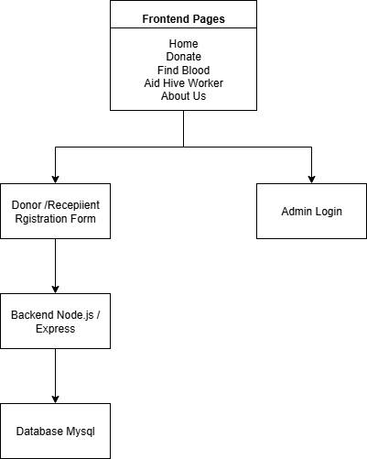

**1. User Module**

The User Module is designed to manage interactions for both donors and recipients through registration forms. Users can access services without the need for login, keeping the process simple and user-friendly.

* **Registration Form:**
* Donors and recipients provide personal details such as name, contact information, blood group, etc.

The form ensures all necessary information is collected to facilitate blood donation and requests.

* **Form Submission:**
  + Once submitted, the backend processes the data and stores it securely in the MySQL database.
* **Interaction with System:**
  + Donors can submit blood donation details.
  + Recipients can request blood and view available options.
  + Users cannot access administrative features; their interaction is limited to the forms and available search functionality.
* **Data Handling:**
  + All user-submitted data is validated for accuracy and stored in the database for further processing by the admin.

This module emphasizes ease of use, secure data collection, and minimal user barriers, allowing donors and recipients to participate in the system quickly and efficiently.

**2. Request Module**

The Request Module handles blood requests from recipients and coordinates them with available donors. It ensures that blood requirements are efficiently captured and processed.

* **Request Form:**
  + Recipients fill out a form specifying their blood group, required quantity, and location.
* **Form Submission:**
  + The backend receives the request data and stores it in the MySQL database.
  + Data validation ensures that all required fields are completed correctly.
* **Processing Requests:**
  + Admin can view submitted requests and match them with available donors.
  + The system updates request status (e.g., pending, approved, completed) for tracking.
* **User Interaction:**
  + Recipients can submit multiple requests but cannot directly access donor information.
  + The module ensures that requests are processed securely and efficiently while keeping user interaction simple.

This module provides a structured and reliable way to manage blood requests while maintaining data integrity and supporting the overall blood donation workflow.

**3. Admin Panel**

The Admin Panel serves as the main control hub for managing the blood donation system. Access is restricted and requires login using a valid username and password. Only authorized admins can perform operations within the panel.

**Key Features:**

* **Login Authentication:**
  + Admin enters username and password to access the panel.
  + Ensures that only authorized personnel can manage the system.
* **User Management:**
  + View donor and recipient details submitted via registration forms.
  + Approve, update, or remove user records as necessary.
* **Request Management:**
  + Monitor and process blood requests submitted by recipients.
  + Assign donors to fulfill requests and update request status (pending, approved, completed).
* **Donation Tracking:**
  + Maintain records of donations submitted by donors.
  + Ensure accurate and secure storage in the MySQL database.

### ***3.2.1 Donor Registration Sequence Diagram***

Figure 3: Donor Registration Sequence Diagram

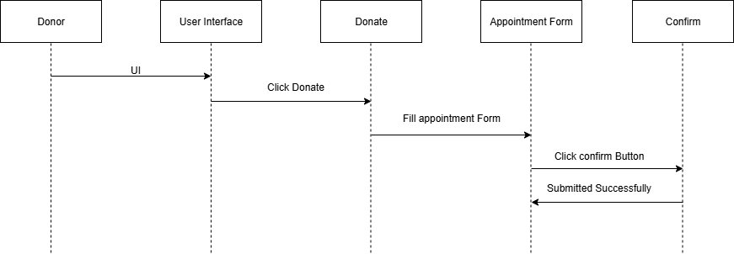

* A donor decides to donate blood.
* The donor goes to the user interface (website or app).
* They choose the "Donate" option.
* The system then shows an appointment form.
* The donor fills out the form with their details.
* After submitting, the system asks the donor to confirm the appointment.
* The donor confirms the submission.
* The donation process is now successfully initiated.

### ***3.2.2 Recipient Registration Sequence Diagram***

Figure 4: Recipient Registration Sequence Diagram

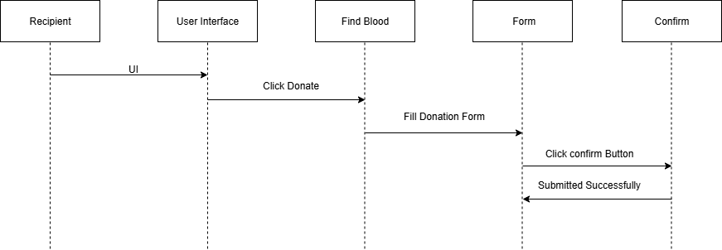

* A recipient needs blood and goes to the user interface (website or app).
* They use the "Find Blood" option.
* The system displays a form to fill in their blood requirements and details.
* The recipient fills out the form and submits it.
* The system then asks them to confirm the request.
* The recipient clicks confirm, and their blood request is successfully sent.

### ***3.2.3 Admin Panel Sequence Diagram***

Figure 5: Admin Panel Sequence Diagram

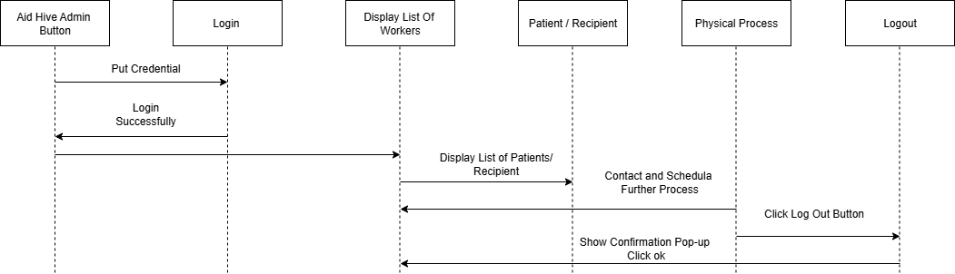

* User clicks on the Aid Hive Admin Button
* User is prompted to login
* After login, system displays list of workers
* A patient or recipient is involved in the process
* A physical process (real-world action like aid or treatment) takes place
* User logs out of the system

***3.2.2 Donor State Transition Diagram***

Figure 6:Donor State Transition Diagram of Aid Hive

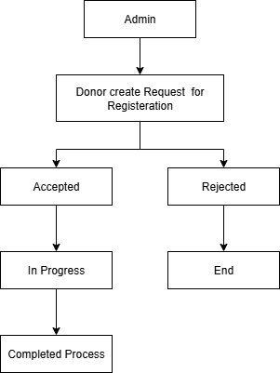

**Explanation:**

1. **Admin (Initial State)**

The process begins with the admin logged into the system.

1. **Donor Creates Request for Registration**

A donor fills the registration form on the platform. The request is forwarded to the admin for verification/approval.

1. **Decision State: Accepted or Rejected**

**If accepted:** the donor’s details are stored in the MySQLdatabase, and the donor can now participate in the system (donating/responding to blood requests).

**If rejected:** the process ends (the donor cannot access the system).

1. **In Progress (For Accepted Requests)**

Once accepted, the donor’s status moves to InProgress, meaning they are now an activedonor in the system.

1. **Completed Process**

When all verification steps are finalized, the donor registration is marked as Completed, and the donor is fully onboarded.

1. **End (For Rejected Requests)**

If the request is not valid, the process terminates without registration.

### ***3.2.4 Recipient State Transition***

Figure 7 : Recipient State Transition Diagram

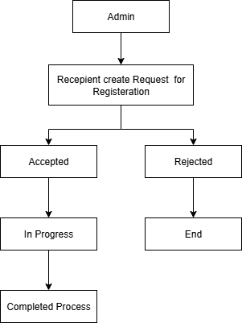

**Explanation:**

1. **Recipient (Start State)**

A recipient (patient or person in need of blood) starts the process by accessing the system via the frontendUI.

1. **Aid Hive Worker**

The request is forwarded to the Aid Hive Worker module, which handles filtering and management of requests.

1. **Listed Donor**

The system retrieves and displays a list of donors from the MySQLdatabase who match the required blood type and selected city.

1. **Check Status – Available or Not**

The system checks the availability status of listed donors:

* + - **Available:** Donor can be contacted for donation.
    - **Not Available:** Donor cannot respond at the moment.

## **3.3 Architectural Design**

The system follows a three-tier architecture consisting of frontend, backend, and database layers to ensure modularity, maintainability, and clear separation of concerns.

1. **Frontend Layer (React.js):**
   * Provides the user interface for donors, recipients, and admins.
   * Donors and recipients interact through registration forms and search functionality.
   * Admin accesses feature only after login using username and password.
   * Pages include Home, Donate, Find Blood, Aid Hive Workers, and About Us, with button OF Aid Hive Admin.
2. **Frontend Layer (React.js):**
   * Provides the user interface for donors, recipients, and admins.
   * Donors and recipients interact through registration forms and search functionality.
   * Admin accesses feature only after login using username and password.
   * Pages include Home, Donate, Find Blood, Aid Hive Workers, and About Us, with button OF Aid Hive Admin.
3. **Backend Layer (Node.js + Express.js):**
   * Handles all API requests from the frontend.
   * Processes form submissions, user requests, and donation tracking.
   * Performs authentication and authorization for the admin.
4. **Database Layer (MySQL):**
   * Stores structured data including users (donors, recipients, admin), blood requests, donations, and worker information.
   * Provides secure and reliable storage to support system operations.

**Data Flow:**

* Users submit forms → Backend validates and stores data → Database updates → Admin monitors and manages requests.

This architecture ensures secure, efficient, and scalable operations while keeping user interactions simple and admin operations centralized.

Figure 8: Architectural Design of Aid Hive

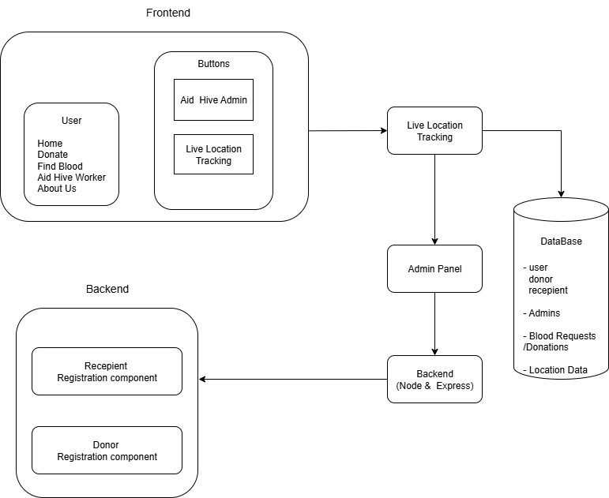

## **3.4 Data Design**

* The Aid Hive: Blood Donation Management System has a MySQL relational database for storing and managing all system data. The security, integrity, and scalability are given priority while designing the system. The database schema has been designed in such a way that every entity like donors, recipients, admins, and blood requests are well defined with the relationships between them.
* Normalization is applied to avoid data redundancy and ensure data consistency.
* Primary keys are used for unique identification of records, and foreign keys maintain relationships between entities.
* The database supports role-based access control, allowing different access privileges for donors, recipients, and admins.

**Key Entities:**

1. Users: Stores information about donors, recipients, and admins.
2. Blood Requests: Manages requests made by patients/recipients.
3. Donations: Tracks donation details and donor contributions.
4. Aid Hive Workers: Maintains records of approved/registered workers.

Figure 9 : ER Diagram

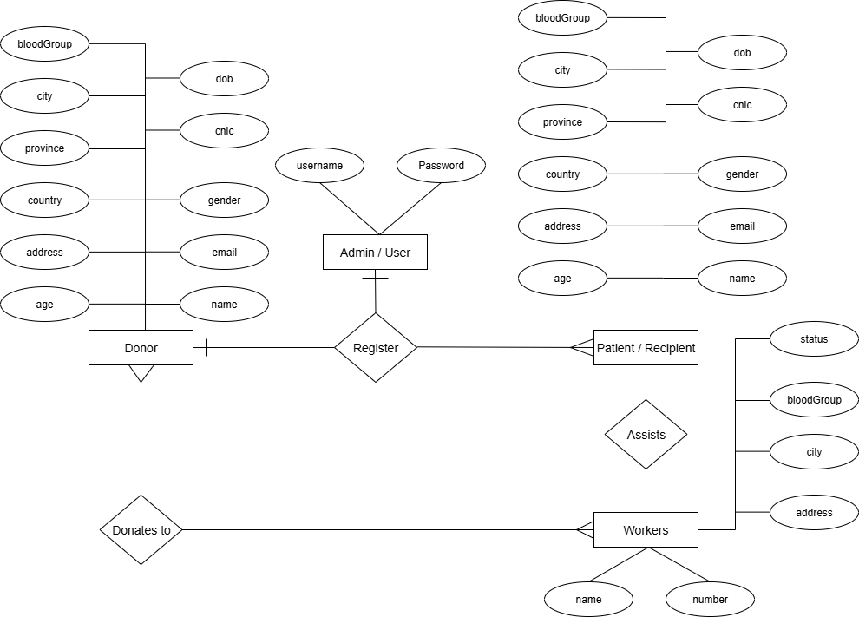

### ***Data Dictionary***

Alphabetical List of System Entities or Major Data with Types and Descriptions:

Table 12: Data Dictionary Table

|  |  |
| --- | --- |
| **Terminology Description** | **Terminology Description** |
| Blood Request | |  | | --- | |  |  |  | | --- | | MySQL table representing a blood donation request | |
| Blood Type | VARCHAR – Type of blood (A+, A-, B+, B-, O+, O-, AB+, AB-) |
| Donor | |  | | --- | |  |  |  | | --- | | MySQL table representing a blood donor | |
| Donor ID | INT (Primary Key, Auto Increment) – Unique identifier for each donor |
| Recipient | My SQL Table representing a person requesting blood |
| Request Status | Enum - Status of blood request (Pending, Approved, Completed) |
| User | My SQL Table storing general user information |

**Structured Approach: Functions and Function Parameters:**

Table 13 : Functions and Function Parameters

|  |  |  |  |
| --- | --- | --- | --- |
| API Endpoint | Description | HTTP Method | Parameters |
| /Api/donors | Retrieves available donors based on location & blood type | GET | (bloodType: String, location: Object) |
| /Api/requests/create | Creating a new blood donation request | POST | (recipientID: ObjectId, bloodType: String, location: Object) |
| /Api/requests/update | Updates request status | PUT | (requestID: ObjectId, status: String) |

## **3.5 User Interface Design**

The User Interface (UI) of the system is designed to be simple, intuitive, and user-friendly for donors, recipients, and admins. It ensures that users can perform their tasks efficiently while keeping navigation straightforward.

Key Pages and Features:

1. **Home Page:**
   * Displays system overview, purpose, and quick navigation links to other pages.
   * Accessible to all users without login.
2. **Donate Page:**
   * Donors can fill out a donation registration form including name, blood group, contact, and donation details.
   * Form submission sends data to the backend for storage.
3. **Find Blood Page:**
   * Recipients can submit blood request forms specifying blood group, quantity.
   * Requests are sent to the backend for processing by admin.
4. **Aid Hive Workers Page:**
   * Displays information about workers involved in blood donation and aid activities.
   * Admin can monitor live location of workers.
5. **About Us Page:**
   * Provides general information about the platform and its objectives.
6. **Buttons:**
   * Aid Hive Admin Button: Redirects to login page for admin authentication.
7. **Forms:**
   * Donor and Recipient forms are simple and mandatory fields are validated to ensure complete and accurate data collection.
   * No login is required for donors or recipients to interact with forms.

**Design Principles:**

* Minimalist and clear layout to reduce confusion.
* Forms with proper labels and placeholders for easy data entry.
* Responsive design for accessibility on desktops, tablets, and mobile devices.
* Admin interface includes authentication and dashboards for effective management.

### ***3.5.1 Screen Images***

Following is the list of screen shots of UI mockups of Aid Hive illustrating the visual design of different components of the Aid Hive.

The subsequent images illustrate the landing page of the Aid Hive. That is the page that the user finds when he opens the app.

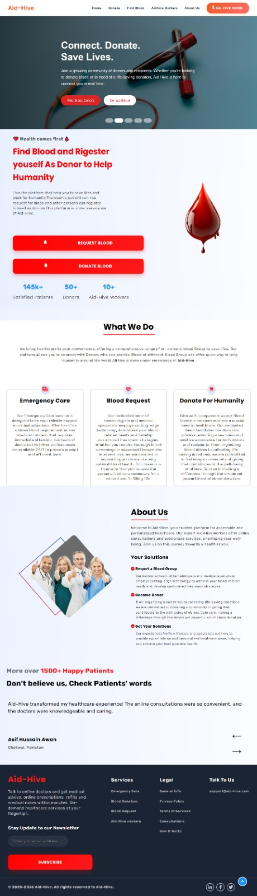Figure 10 : Landing Page

The following image show case the Admin Login Form up of the Aid Hive.

Figure 11 : Admin Login Form

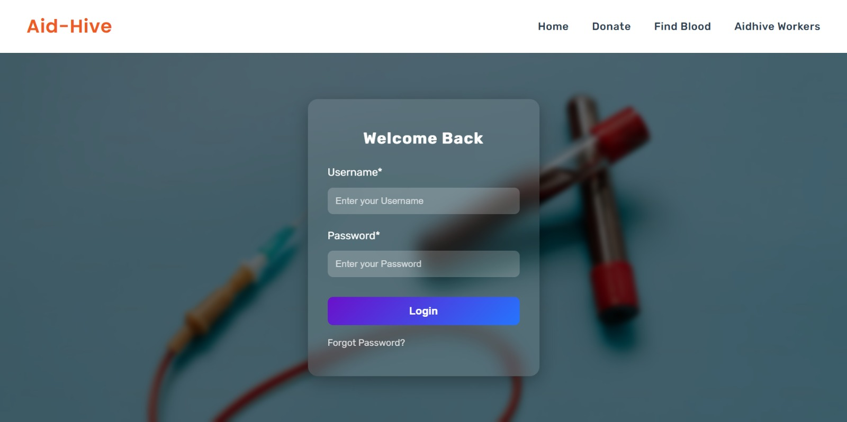

The following image show case the Donor Registration Form up of the Aid Hive.

Figure 12 : Donor Registration Form

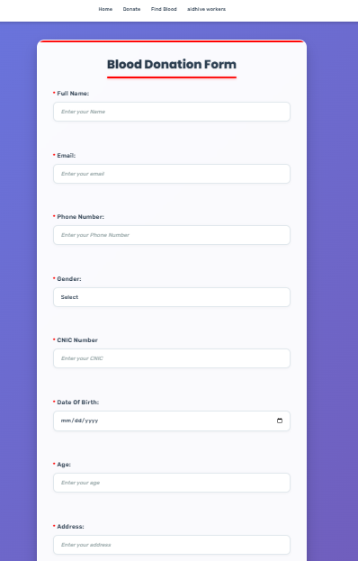

The following image show case the Recipient Registration Form up of the Aid Hive.

Figure 13 : Recipient Registration Form

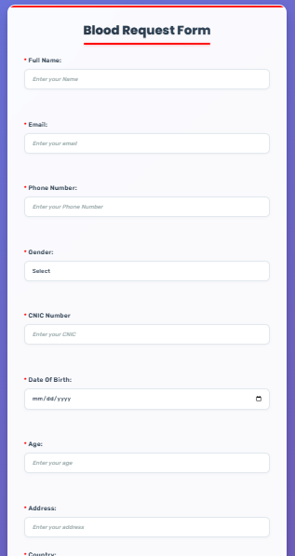

### ***3.5.2 Screen Objects and Actions***

***Use Case 1: Donor Registration***

Table 14: Use case 1

|  |  |
| --- | --- |
| **Use Case ID** | UC-01 |
| **Actor** | Donor |
| **Description** | Allows a donor to register and provide their details for blood donation. |
| **Preconditions** | Donor has internet access and opens the Donate page. |
| **Postconditions** | Donor’s information is stored in the MySQL database. |

**Main Flow:**

1. Donor navigates to the Donate page.
2. Donor fills out the registration form.
3. Donor submits the form.
4. Backend validates and stores the information in the database.
5. System displays a confirmation message.

**Alternate Flow:**

* If the form is incomplete or contains invalid data, the system shows an error message and prompts the donor to correct it.

***Use Case 2: Recipient Registration***

Table 16: Use case 1

|  |  |
| --- | --- |
| **Use Case ID** | UC-02 |
| **Actor** | Recipient |
| **Description** | Allows a Recipient to register and provide their details for blood donation. |
| **Preconditions** | Recipient has internet access and opens the find blood page. |
| **Postconditions** | Recipient’s information is stored in the MySQL database. |

**Main Flow:**

1. Recipient navigates to the find blood page.
2. Recipient fills out the registration form.
3. Recipient submits the form.
4. Backend validates and stores the information in the database.
5. System displays a confirmation message.

**Alternate Flow:**

* If the form is incomplete or contains invalid data, the system shows an error message and prompts the Recipient to correct it.

***Use Case 3: Admin Processing Blood Requests***

Table 17: Use case 2

|  |  |
| --- | --- |
| **Use Case ID** | UC-02 |
| **Actor** | Admin |
| **Description** | Allows the admin to view, manage, and approve blood requests submitted by recipients. |
| **Preconditions** | Admin must be logged in using username and password. |
| **Postconditions** | Blood request status is updated in the database and donor assignment is recorded. |

**Main Flow:**

1. Admin logs in to the Admin Panel.
2. Admin navigates to the Request Management section.
3. Admin views pending blood requests submitted by recipients.
4. Admin assigns available donors to requests and updates status (approved/pending/completed).
5. Backend updates the database and sends confirmation to the recipient.

**Alternate Flow:**

* If no matching donors are available, the system keeps the request in pending status and notifies the admin.

## **Behavioral Model**

**Sequence Diagrams:**

### ***3.6.1 Admin login***

Figure 14: Admin login

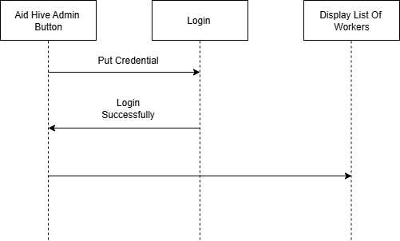

### ***3.6.2*** ***List of Worker / Add Worker***

Figure 15: List of Worker / Add Worker

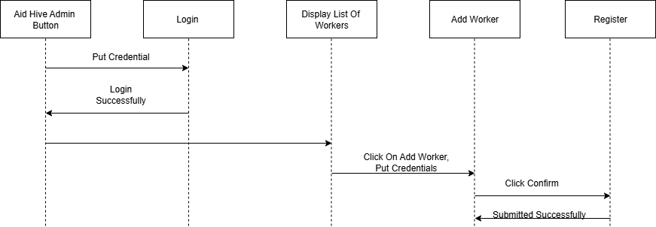

### ***3.6.3 Delete Worker***

Figure 16: Delete Worker

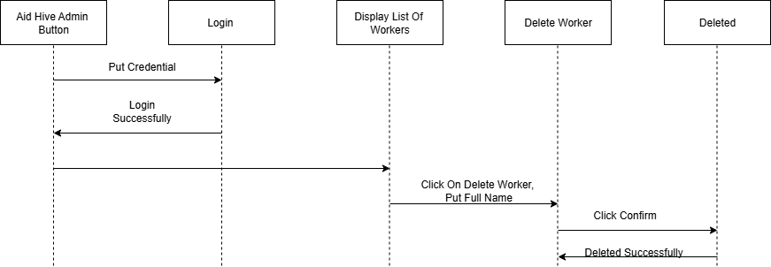

### ***3.6.4 Display Listed Donors***

Figure 17: Display Listed Donor

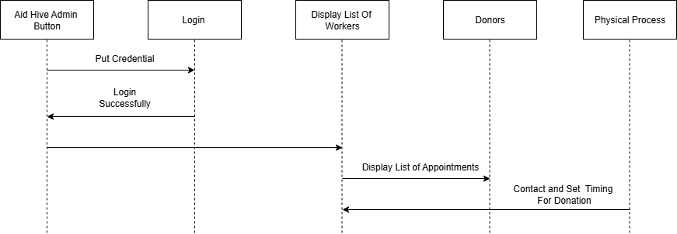

### ***3.6.5 Display Listed Recipient***

Figure 18 : Display Listed Recipient

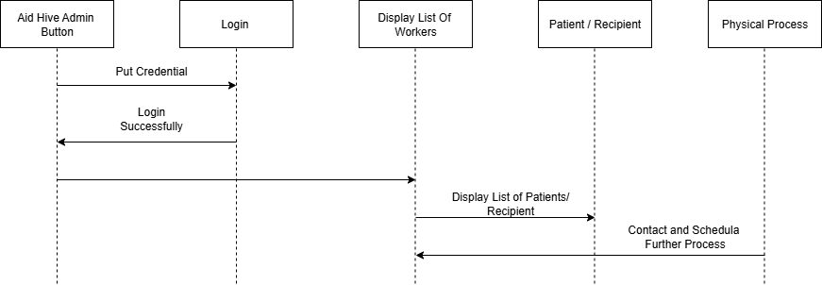

### ***3.6.6 Logout***

Figure 19: Logout



### ***3.6.7 Donor Registration***

Figure 20: Donor Registration



### ***3.6.8 Recipient Registration***

Figure 21: Recipient Registration

**s*****3.6.9 Donor / Recipient Display Worker List***

Figure 22: Donor / Recipient Display Worker List

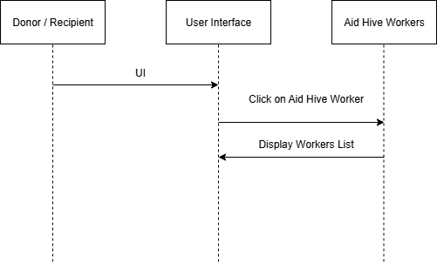

**Collaboration Diagrams:**

### ***3.6.10 Admin Login***

Figure 23 :Admin Login

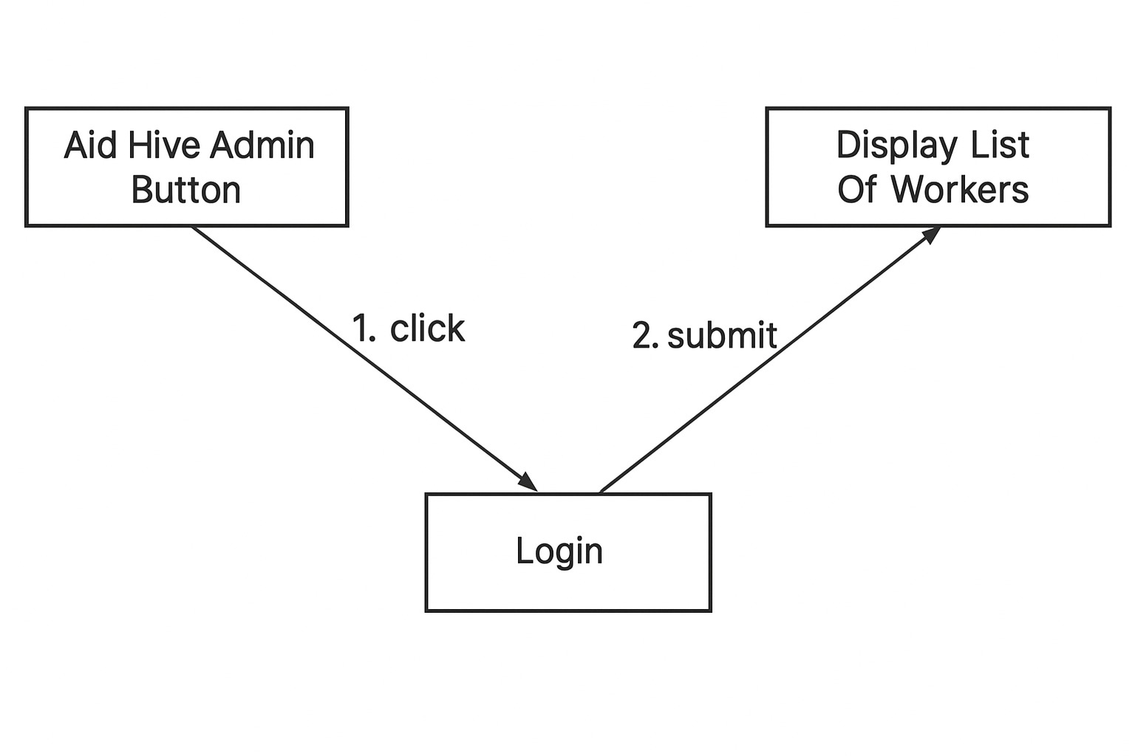

### ***3.6.11 List of Worker / Add Worker***

Figure 24: List of Worker / Add Worker

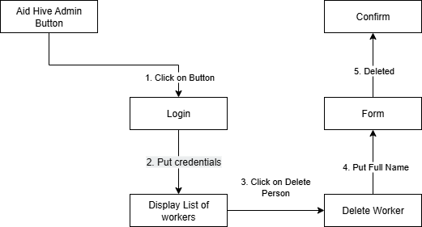

### ***3.6.12 Delete Worker***

Figure 25: Delete Worker



### ***3.6.13 Display Listed Donor / Recipient***

Figure 26: Display Listed Donor / Recipient

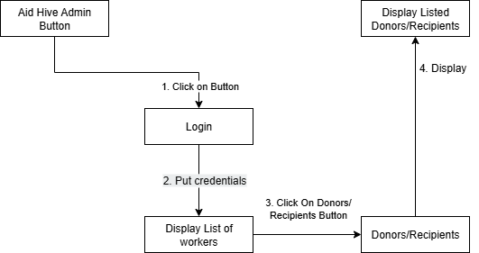

### ***3.6.14 Donor / Recipient Registration***

Figure 27: Donor / Recipient Registration

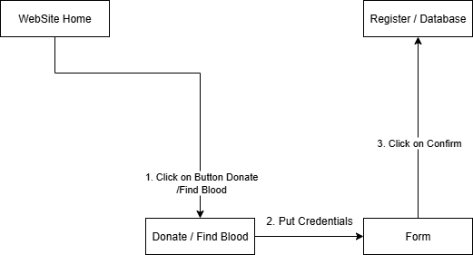

***3.6.15 Donor / Recipient Display Worker List***

Figure 28: Donor / Recipient Display Worker List

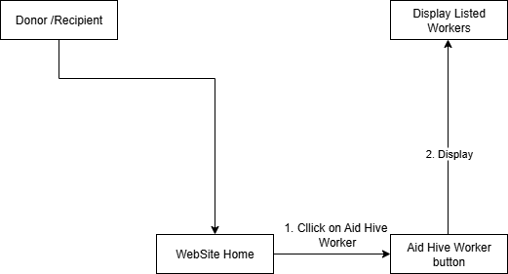

## **3.7 Design Decisions**

The design decisions focus on simplicity, security, and proper role-based access:

1. **MERN Stack with MySQL:**
   * Frontend: React.js
   * Backend: Node.js + Express.js
   * Database: MySQL for structured data storage
2. **Form-Based Interaction for Users:**
   * Donors and recipients interact only through registration and blood request forms.
   * No login is required for users to submit data.
3. **Admin Login Authentication:**
   * Admin can access the system only via username and password.
   * Ensures secure and authorized management of the system.
4. **Three-Tier Architecture:**
   * Separation of frontend, backend, and database layers improves maintainability and scalability.
5. **User-Friendly Interface:**
   * Simple navigation and clear forms make donor and recipient interactions easy.
   * Admin panel is designed for efficient management and monitoring.
6. **Data Validation and Security:**
   * Form inputs are validated before submission.
   * Sensitive data is secured through backend and database protocols.

## **3.8 Summary**

The Aid Hive Platform System Design is all about designing an efficient, secure, and accessible system. The donors and the recipients are in interaction only with the blood request forms and registration forms, whereas the admins use username and password login to enter the system. The system is deployed using a MERN stack along with MySQL for storing structured data and a three-tier architecture with layers of frontend, backend, and database.

**Chapter 4**

**Implementation**

# **4. Implementation**

This chapter covers the implementation of the Aid Hive Blood Donation Management System. It explains how the designed modules were developed using MERN stack with MySQL database integration.

## **4.1 Code Repository**

For version control, collaborative development, and efficient project management, the Aid Hive blood donation web application used Git as the main version control system. The repository included all source code, frontend and backend components, documentation, and related project resources. Using Git allowed the team to track changes, resolve conflicts, and collaborate effectively while working with the MERN stack. The repository served as a single source of truth, ensuring that all team members worked with the latest version of the system and enabling smooth coordination throughout the development process.

**Git Repository Link**

[https://github.com/Abdur-Rehman153/Aid Hive.git](https://github.com/Abdur-Rehman153/Aid-Hive.git).

## **4.2 Summary**

The Implementation chapter elaborates that creating an efficient and secure blood donation portal with the MERN stack and MySQL as the database. The frontend was implemented using React.js and made responsive and easy to use, while the backend from Node.js and Express.js managed data operations, API routing, and admin features. Essential features like donor registration, recipient blood requests. Admin access is maintained through username and password login, and the system checks all form submissions for data integrity. All modules were thoroughly tested for performance, security, and systems requirements for real-time donation and recipient connection.

**Chapter 5**

**Testing and Evaluation**

# **5. Introduction**

Testing and Evaluation of Aid Hive is designed to ensure the system works satisfactorily and meets user expectations. Throughout the development process, testing is used to confirm all the functionality from user sign-up and logon to donor matching and blood requests work correctly under different conditions.

Key principles guiding the testing process include:

* Conducting independent testing that does not rely on other test results.
* Writing short and clear statements to validate expected outcomes.
* Using test data properly with setup and teardown methods.
* Avoiding hardcoded values to make tests adaptable.
* Ensuring tests are repeatable and reliable each time they are executed.

## **5.1 Unit Testing (UT)**

Unit testing entails testing separate components or functions of the Aid Hive system to ensure that each component works as it is supposed too independently. These are done early in development to catch small issues before they become big issues.

### ***5.1.1 Donor Registration***

Table 15: User Registration

|  |  |
| --- | --- |
| Testcase ID | UT-1 |
| Requirement ID | FR-1 (Donor-Registration) |
| Title | Register New Donor |
| Description | Tests if a new donor can register successfully |
| Objective | Ensure system stores new donor data correctly |
| Driver/precondition | User is not already registered |
| Test steps | |  | | --- | |  |  |  | | --- | | 1. Open registration form 2. Enter valid info 3. Submit 4. Check database | |
| Input | |  | | --- | |  |  |  | | --- | | Ali Hassan, contact.abhassan@gmail.com, Gujranwala, Hafizabad Road Sharukh colony, B+, 1234 | |
| Expected Results | Form loads, data accepted, success message, new record exists |
| Actual Result | From loads  Data accepted  Redirected with success  User found in database |
| Remarks | Pass |

### ***5.1.2 Recipient Registration***

Table 16: Recipient Registration

|  |  |
| --- | --- |
| Testcase ID | UT-2 |
| Requirement ID | FR-2 (Recipient Registration) |
| Title | Register New Recipient |
| Description | Tests if a new recipient can register successfully |
| Objective | |  | | --- | |  |  |  | | --- | | Ensure system stores new recipient data correctly | |
| Driver/precondition | |  | | --- | |  |  |  | | --- | | User is not already registered | |
| Test steps | 1. Open registration form 2. Enter valid info 3. Submit 4. Check database |
| Input | Sara Khan, sara.khan@gmail.com, Lahore, Gulberg, O-, 5678 |
| Expected Results | |  | | --- | |  |  |  | | --- | | Form loads, data accepted, success message, new record exists | |
| Actual Result | Success + redirect  Error shown  Error shown |
| Remarks | Pass |

### ***5.1.3 Admin Login***

Table 17: Admin Login

|  |  |
| --- | --- |
| Testcase ID | UT-3 |
| Requirement ID | FR-2 (Admin Login) |
| Title | Admin Login |
| Description | Tests if admin can login with correct credentials |
| Objective | |  | | --- | |  |  |  | | --- | | Ensure admin access works | |
| Driver/precondition | Admin account exists |
| Test steps | 1. Open admin login 2. Enter credentials 3. Submit |
| Input | |  | | --- | |  |  |  | | --- | | admin@aidhive.com, password123 | |
| Expected Results | Login successful, dashboard opens |
| Actual Result | Successful login |
| Remarks | Pass |

***5.1.4 Find Blood***

Table 18: Find Blood

|  |  |
| --- | --- |
| Testcase ID | UT-4 |
| Requirement ID | FR-4 (Find Blood) |
| Title | Search Blood Donors |
| Description | Tests if the system returns correct donors based on blood group & city |
| Objective | Ensure blood search works accurately |
| Driver/precondition | Donors exist in database |
| Test steps | 1. Open Find Blood page 2. Enter blood group & city 3. Submit search |
| Input | |  | | --- | |  |  |  | | --- | | Blood Group: B+, City: Gujranwala | |
| Expected Results | |  | | --- | |  |  |  | | --- | | List of matching donors displayed | |
| Actual Result | Blood Matched |
| Remarks | Pass |

## **5.2 Functional Testing (FT)**

Functional testing is done to make sure that all the critical functionalities and user-oriented modules of Aid Hive function as desired. The goal is to make sure the system is as per the functional specifications and that the system is usable by all the stakeholders (Donor, Recipient, Admin) efficiently.

**5.2.1 Donor Registration**

Table 19: Donor Registration

|  |  |
| --- | --- |
| **Testcase ID** | FT-1 |
| **Requirement ID** | FR-1 (Donor Registration) |
| **Title** | Verify Donor Registration |
| **Description** | |  | | --- | |  |  |  | | --- | | Ensures a donor can register successfully with valid inputs | |
| **Objective** | Confirm donor data is stored correctly |
| **Driver/precondition** | User is not already registered |
| **Test steps** | |  | | --- | |  |  |  | | --- | | Open form → Enter valid info → Submit → Verify database | |
| **Input** | |  | | --- | |  |  |  | | --- | | Ali Hassan, contact.abhassan@gmail.com, Gujranwala, Hafizabad Road Sharukh colony, B+, 1234 | |
| **Expected Result** | Form submits, success message, new record created |
| **Actual Result** | Works as expected |
| **Remarks** | Pass |

### ***5.2.2 Recipient Registration***

Table 20: Recipient Registration

|  |  |
| --- | --- |
| **Testcase ID** | FT-2 |
| **Requirement ID** | FR-3 (Recipient Registration) |
| **Title** | Verify Recipient Registration |
| **Description** | Ensures a recipient can register successfully with valid inputs |
| **Objective** | Confirm recipient data is stored correctly |
| **Driver/precondition** | |  | | --- | |  |  |  | | --- | | User is not already registered | |
| **Test steps** | Open form → Enter valid info → Submit → Verify database |
| **Input** | Sara Khan, sara.khan@gmail.com, Lahore, Gulberg, O-, 5678 |
| **Expected Result** | Form submits, success message, new record created |
| **Actual Result** | Successfully registered |
| **Remarks** | Pass |

### ***5.2.3 Admin Login***

Table 21: Admin login

|  |  |
| --- | --- |
| **Testcase ID** | FT-3 |
| **Requirement ID** | FR-4 (Admin Login) |
| **Title** | Verify Admin Login |
| **Description** | |  | | --- | |  |  |  | | --- | | Ensures admin can login with correct credentials | |
| **Objective** | Confirm admin access works properly |
| **Driver/precondition** | |  | | --- | |  |  |  | | --- | | Admin account exists | |
| **Test steps** | Open login → Enter credentials → Submit |
| **Input** | |  | | --- | |  |  |  | | --- | | admin@aidhive.com, password123 | |
| **Expected Result** | Admin dashboard opens |
| **Actual Result** | Successfully Login |
| **Remarks** | Pass |

### ***5.2.4 Admin Panel Controls***

Table 22: Admin Control

|  |  |
| --- | --- |
| **Testcase ID** | FT-5 |
| **Requirement ID** | FR-5 (Admin Dashboard) |
| **Title** | View Users and Deactivate Account |
| **Description** | Admin views users/requests and deactivates accounts |
| **Objective** | Ensure administrative functions perform correctly |
| **Driver/precondition** | Admin logged in |
| **Test steps** | Login → View → Deactivate |
| **Input** | User ID = 1098 |
| **Expected Result** | User status changes to inactive |
| **Actual Result** | Successfully updated |
| **Remarks** | Pass |

## **5.3 Integration Testing (IT)**

Integration testing was done after all the separate unit tests were successfully finished. Integration testing consisted of testing interactions of sets of modules to ensure that the overall flow of the features gives the desired outputs.

### ***Request Submission Flow***

Table 23: Test Case 1

|  |  |
| --- | --- |
| **Testcase ID** | IT-1 |
| **Requirement ID** | FR-1, FR-2 |
| **Title** | User Registration to Request Flow |
| **Description** | |  | | --- | |  |  |  | | --- | | Ensures system returns accurate donors based on blood group & city | |
| **Objective** | Confirm blood search works correctly |
| **Precondition** | Donor exists in database |
| **Test steps** | |  | | --- | |  |  |  | | --- | | Open Find Blood → Enter blood group & city → Submit | |
| **Input** | |  | | --- | |  |  |  | | --- | | Blood Group: B+, City: Gujranwala |   and further fields |
| **Expected Result** | Matching donors displayed |
| **Actual Result** | Works as expected |
| **Remarks** | Pass |

### ***5.3.2 User Login Blocked***

Table 24: Test Case 2

|  |  |
| --- | --- |
| **Testcase ID** | IT-2 |
| **Requirement ID** | FR-1, FR-5 |
| **Title** | Admin Deactivates User → Prevent Login |
| **Description** | Ensure admin block prevents user access via login |
| **Objective** | Validate integration of admin actions and authentication logic |
| **Precondition** | User exists; admin has access |
| **Test steps** | User tries login |
| **Input** | Username: admin, password: admin1234 |
| **Expected Result** | Login fails with “Wrong Username or password” message |
| **Actual Result** | As expected, |
| **Remarks** | Pass |

### ***5.3.3 Matches with User History***

Table 25: Test Case 3

|  |  |
| --- | --- |
| **Testcase ID** | IT-6 |
| **Requirement ID** | FR-5, FR-2 |
| **Title** | Admin Review of User History |
| **Description** | Admin checks if user request logs match with system-wide records |
| **Objective** | Ensure transparency and data syncing between user and admin views |
| **Precondition** | Admin and recipient both logged in |
| **Test steps** | User submits → Admin reviews logs |
| **Input** | User ID = 3012, Request ID = 1204 |
| **Expected Result** | Admin sees same request data as recipient |
| **Actual Result** | Matched perfectly |
| **Remarks** | Pass |

## **5.4 Performance Testing (PT)**

Following the testing of each module and integration, performance testing was done to determine the behavior of the system under stress, heavy load, and concurrent usage states. These were performed on response time, reliability, and stability.

### ***Login API Response Time***

Table 26: Test Case 1

|  |  |
| --- | --- |
| **Testcase ID** | PT-1 |
| **Requirement ID** | FR-1 |
| **Title** | Login API Performance |
| **Description** | Test login response time with multiple simultaneous users |
| **Objective** | Ensure system handles authentication quickly under load |
| **Precondition** | 4 users attempt login (valid & invalid credentials) |
| **Test steps** | Simulate login requests → Measure response time |
| **Input** | Email/password for 4 users |
| **Expected Result** | Response time < 1 second |
| **Actual Result** | ~350ms average |
| **Remarks** | Pass |

### ***5.4.2 Request Creation Under Load***

Table 27: Test Case 2

|  |  |
| --- | --- |
| **Testcase ID** | PT-2 |
| **Requirement ID** | FR-2 |
| **Title** | Request for Submission Load Performance |
| **Description** | Assess how request creation behaves under simultaneous usage |
| **Objective** | Ensure the system remains responsive with multiple users |
| **Driver/precondition** | 100 recipients submit blood requests at once |
| **Test steps** | Simulate load → Submit requests → Record time |
| **Input** | Request payloads with blood type, location, urgency |
| **Expected Result** | < 2 seconds per request |
| **Actual Result** | ~1.5 seconds |
| **Remarks** | Pass |

### ***5.4.3 Admin Panel Performance***

Table 28: Test Case 3

|  |  |
| --- | --- |
| **Testcase ID** | PT-5 |
| **Requirement ID** | FR-5 |
| **Title** | Admin Dashboard Load Time |
| **Description** | Test how fast admin panel loads user and request data |
| **Objective** | Confirm UI responsiveness and database query performance |
| **Driver/precondition** | Admin logged in |
| **Test steps** | Access dashboard → View user & request tables |
| **Input** | Admin access to system database |
| **Expected Result** | Load time < 1.5 seconds |
| **Actual Result** | ~910ms |
| **Remarks** | Pass |

## **5.5 Summary**

This chapter describes the testing of the Aid Hive Blood Donation Management System. Different types of testing such as unit, functional, integration, and performance were applied on modules like authentication, donor–recipient requests, donor matching, and admin features. The system worked correctly, responded efficiently, and fulfilled the functional requirements, showing that Aid Hive is reliable and ready for deployment.

**Chapter 6**

**System Conversion**

# **6. Introduction**

The System Conversion from Aid Hive updates the conventional, manual procedures of blood donations to a centralized, web-based system. Major operations like donor registration, management of blood requests, matching of donors and recipients are relocated to an efficient online platform, thereby accelerating the process, making it more efficient and friendly to use.

## **6.1 Conversion Method**

For the Aid Hive system, a direct conversion method is used. This means the manual and standalone processes of blood donation (such as paper-based donor lists, offline request handling, and manual matching) are replaced immediately by the new centralized web-based system.

The direct conversion approach was chosen because:

* The system is relatively new and not dependent on heavy legacy infrastructure.
* It ensures all users (donors, recipients, and admin) interact with a single updated platform without relying on outdated methods.

***Direct Conversion***

The Aid Hive system adopts a Direct Conversion method, where the existing manual blood donation process is completely replaced by the new web-based system in a single step. Once the system is deployed, all stakeholders—including donors, recipients, and administrators—will begin using the new platform comfortably, without relying on old manual methods.

This approach was selected because it provides:

* Immediate transition to a centralized system for blood donation.
* Elimination of duplicate processes, ensuring everyone uses one updated platform.
* Faster adoption by all users, as the old paper-based procedures are discontinued.

***Parallel Conversion***

The Aid Hive system uses a Parallel Conversion method, in which the new web-based platform runs side by side with the existing manual process for a limited period of time. During this phase, blood donation requests, donor registrations, and recipient matching are handled both manually and through the Aid Hive portal.

This method was chosen because it:

* Provides a safety net, as the old system continues to function until the new system is fully reliable.
* Helps detect and fix any technical issues in the Aid Hive system without interrupting ongoing blood donation activities.
* Allows users to gradually adapt to the new system, reducing training challenges and resistance.

***Pilot Conversion***

The Aid Hive system can also be deployed using a Pilot Conversion method, where the new web-based blood donation platform is first introduced to a small group of users or a specific region before being rolled out organization-wide. In this approach, a limited number of donors, recipients, and administrators are given access to the Aid Hive system to perform real-world tasks such as donor registration, blood request posting, and location-based donor searches.

***Suitability for Aid Hive***

For the Aid Hive system, the most suitable approach is a Pilot Conversion, where the platform is first introduced to a limited group of users such as a single hospital, a specific blood bank, or a small community of donors and recipients. In this pilot phase, the selected group will use the Aid Hive system for donor registration, blood requests and while the rest of the users continue with the manual process.

***Phased Conversion***

In the Phased Conversion approach, the Aid Hive system is implemented gradually in stages, rather than all at once. Specific modules such as Donor Registration, Blood Request Posting and Admin Panel are rolled out one after another, allowing each component to be tested and stabilized before moving on to the next.

***Suitability for Aid Hive***

The Phased Conversion method is suitable for Aid Hive because it allows the system to be introduced step by step instead of all at once. Since Aid Hive contains multiple critical modules such as Donor Registration, Blood Request Management and Admin Panel rolling them out in phases ensures that each feature is properly tested, validated, and accepted by users before moving forward.

## **6.2 Summary**

The Aid Hive system was converted from a manual blood donation process into a centralized, web-based platform using a structured conversion strategy. Different methods such as Direct, Parallel, Pilot, and Phased Conversion were considered, with Phased Conversion identified as the most suitable due to its low risk, gradual rollout, and ease of user adoption. This ensured that modules like Donor Registration, Blood Requests and Admin Panel were introduced step by step, minimizing errors. The conversion process successfully established a reliable, user-friendly, and efficient system.

**Chapter 7**

**Conclusion**

# **7. Introduction**

The Aid Hive Blood Donation Management System, built on the MERN stack with MySQL, streamlines blood donation through five pages Home, Donate, Find Blood, Aid Hive Workers, and About Us with one key feature: admin panel. Donors and recipients only interact by filling registration forms, while data management and approvals are handled securely by the admin. This simple yet effective structure makes the system user-friendly, reliable, and well-organized for managing blood donation activities.

## **7.1 Evaluation**

Table 29 : Evaluation Table

|  |  |
| --- | --- |
| **Objectives** | **Status** |
| Allow donors to update their availability status directly from their dashboard. | Completed |
| Keep user data secure and private, complying with standard security practices. | Completed |
| Ensure the system is fully responsive and works well on desktops, laptops, and mobile devices. | Completed |
| Provide a clear and user-friendly interface using React.js and Tailwind CSS. | Completed |
| Allow admins to manage donor and recipient requests. | Completed |
| Provide role-based dashboards for both donors and recipients with personalized features. | Completed |
| Store and manage donation and request history for all registered users. | Completed |

## **7.2 Traceability Matrix**

Following is a table of all the requirements for Aid Hive with their brief description and design specifications.

Table 30 : Requirement Traceability Matrix

|  |  |  |  |  |
| --- | --- | --- | --- | --- |
| **Requirement ID** | **Requirement Description** | **Design Specification** | **Code** | **Test ID** |
| R1 | The system must allow users to store and retrieve blood donor/recipient profiles and request data. | Component: *User Authentication*, *Profile Management* | auth.js, user.js, profileRoutes.js | T01 |
| R2 | The system must recommend blood donors based on location and blood type. | Component: *AI-Powered Recommendation Engine* | matchEngine.js, donorFilter.js | T02 |
| R3 | The system must track the status of blood requests (pending, fulfilled, etc.). | Component: *Request Status Tracking* | requestStatus.js, requestRoutes.js | T04 |
| R4 | The system must allow users to view their donation history and track past activities. | Component: *Donation History Management* | history.js, userDashboard.js | T05 |
| R5 | The system must provide a user-friendly interface for donation and request submission. | Component: *User Interface Design* | Form Component.js requestForm.css | T06 |
| R6 | History management for tracking past donations. | Design: *Database Logging (My sql)* | mysql.js, donationLogs.js | T07 |

## **7.3 Conclusion**

In conclusion, Aid Hive offers a straightforward yet efficient platform for linking blood donors and recipients with the system remaining secure and controlled via the admin panel. Recipients and donors only communicate through the completion of registration forms, and admin controls all records and approvals via a safe login. The organized mechanism enables user-friendliness, reliability, and proper management of blood donation activities, making the system a feasible solution for processing the donation procedure.

***Correlation Table: Objectives vs. Functionality***

Table 31 : Correlation Table

|  |  |
| --- | --- |
| **Defined Objective** | **Functionality Provided** |
| Strong Security Purposes | Password hashing by bcrypt, login-brute force protection |
| Easy access and usability across all devices | Fully responsive frontend using React.js and Tailwind CSS |
| Track and manage blood donation history | Profile management with past donation forms stored in My SQL |
| Simplified blood request process | Structured request forms with validation and user-friendly submission interface |

## 

## **7.4 Future Work**

Even though the Aid Hive system has fulfilled its original objectives, there is always potential for future growth and expansion. Among the proposed advancements are:

• **Mobile Application Development**:

To improve accessibility and convenience for users while they are on the go, a cross-platform mobile application version will be developed.

• **AI-Based Donor Matching**:

This method uses computer programs with artificial intelligence to suggest the best donors based on urgency and historical data.

• **Multilingual Support**:

Providing multilingual support will make the platform more accessible to users from various geographical locations.

• **Hospital Integration**:

Enabling real-time donor data viewing and mass donation campaign management for hospital accounts.

**• Offline Alert System**:

In places with poor internet connectivity, use SMS-based alert systems.

### **References**

MySQL Documentation. Retrieved from

<https://www.mysql.com/docs/manual/>

React. (n.d.). React.js Documentation. Retrieved from

<https://react.dev/>

Tailwind CSS. (n.d.). Tailwind CSS Documentation. Retrieved from

<https://tailwindcss.com/>

Express. (n.d.). Express.js Documentation. Retrieved from

<https://expressjs.com/>

Node.js. (n.d.). Node.js Documentation. Retrieved from

<https://nodejs.org/docs/latest/api/documentation.html>

Google. "OAuth 2.0 for Web Applications." Internet:

<https://developers.google.com/identity/protocols/oauth2/>

# **Appendix A**

# **Use case Description Template**

Appendix-A Use Case Description (Fully Dressed Format)

The Table A-1 below indicates a comprehensive use case template

Table 32 : Show the detail use case template and example

|  |  |
| --- | --- |
| **Use Case ID** | UC-1 |
| **Use Case Name** | Register as a Blood Donor |
| **Actors** | Donor (User), System (Aid Hive Web App) |
| **Description** | This use case allows a new user to register as a blood donor by filling in their personal information, blood type, and availability. Once registered, they can be matched with recipients. |
| **Trigger** | The donor clicks on the "Donate" button on the homepage or navbar. |
| **Preconditions** | The donor must have internet access and a valid email address. |
| **Postconditions** | The donor's data is saved in MySQL, and they receive a confirmation email via Node mailer. They are redirected to the donor dashboard. |
| Normal Flow | Donor navigates to the "Donor Registration" page. System displays the registration form. Donor enters full name, email, password, blood type, location, and availability. Donor clicks the "Submit" button. Frontend (React) performs validation on all fields (e.g., required fields, email format, password strength) If valid, form data is sent via Axios to the Express.js backend. Backend hashes the password using crypt, stores the data in My SQL. System sends a confirmation email using Node mailer. System responds with a success message and redirects to the dashboard. |
| Alternative Flows | AF-1: *(At Step 3)* If the user enters an already registered email address, the system displays an error message: *"Email already exists."*  AF-2: *(At Step 5)* If any field is invalid (e.g., empty or wrong format), the system highlights the error and disables submission. |
| Business Rules | Only users 18 years and above can register. Blood type must be selected from a fixed dropdown list. Donors must confirm availability status (Yes/No). Email format must match RFC 5322 standards. Password must have at least 8 characters including uppercase, lowercase, and numbers. Backend checks for existing accounts to prevent duplicates. |